**Instructions to perform an Active Directory Bare Metal Recovery**

**Synopsis:** This document aims to give instruction on to use Bare Metal Recovery for multiple functions. You can use this for Disaster Recovery, Migrations from onprem to the cloud, and even upgrading to Generation 2 VMs

**Servers: restoserver**

**Prep:**

Restore Server: This server has nested Hyper-V

(Take note of the server size and processor, it needs to be hyper-threaded. Nested Hyper-V means you can run Hyper-V on a VM)

1. Boot server and download the latest windows server build .iso
2. Make sure the disks for the new/restored server is mounted within Azure but offline within windows disk management.. In this case it is a domain controller, which has a 127gb boot, 60gb sysvol, 60gb logs.

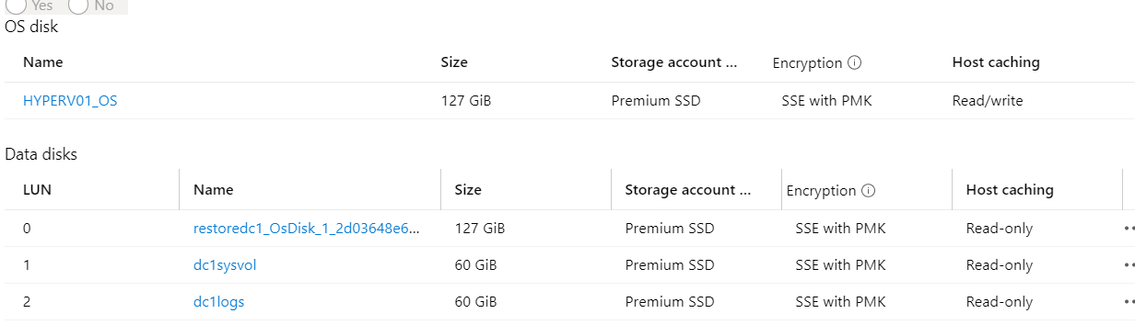

1. If they are not mounted you can create the 2 data disks (generation1) and mount them on the restore server
2. To create the os drive, it’s fastest to build a new azure vm, then once it’s done delete the vm and mount the orphaned drive, as far as LUN goes this drive should be first

**Restore Data:**

1. Within Azure on SQL1 look for the restore disks, it should be named nn

a. DCRestoreDisk1 for DC1

b. DCRestoreDisk2.for DC2.

1. If they are not there, create them 64gb premium disk.

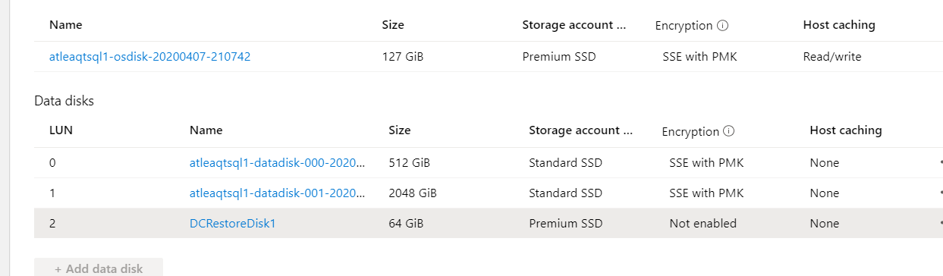

1. Once mounted find the image you want to restore. Navigate down to the folder “WindowsImage” to the root of DCRestoreDisk(#). Robocopy is faster than the GUI
   1. Mkdir (DCRestoredisk drive letter):\WindowsImageBackup
   2. Robocopy /mir /s /e (path to restore image windowsimageBackup) (??:\WindowsImageBackup)

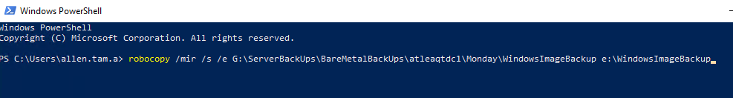

1. Dismount drive when copy is finished and mount onto the restore server. Its easiest to do 1 server at a time, meaning if you’re going to restore DC1 mount only the drives for DC1. This will prevent things from getting confusing

**Hard Disk and Hyper-v:**

1. On the restore server, open disk management, make sure all mounted disks are offline Make note of which disk is which.

Below are before and after screens shots of the drives online and offline ,

Online: 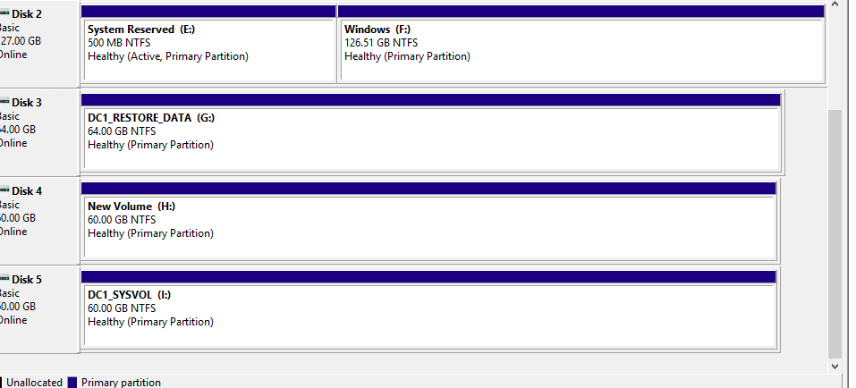

Offline:

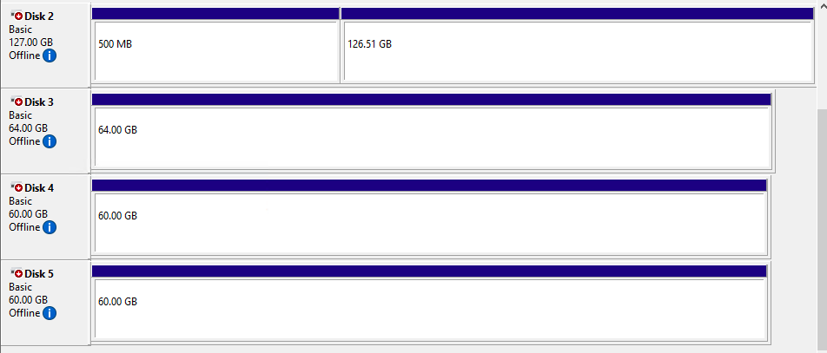

1. Open Hyper-v manager, create a new vm, 2gb RAM, and give it the name of the server you are restoring, but do not create the disk. Just create a vm with no drives
2. Once vm is created right click, and modify the vm. On the left panel select IDE Controller 0. Then click Add, select Physical Hard Drive and select the OS drive in slot1, Then Sysvol in slot 2. 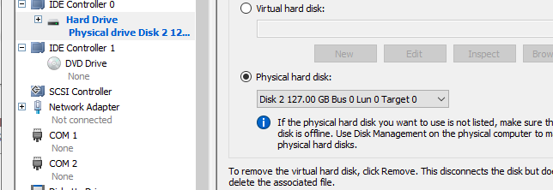
3. Select IDE Controller 1 remove the dvd drive in slot 0. Click save, exit the configure Hyper-V VM, and edit it again (there’s a bug with Hyper-v if you pass or skip a disk in the selection pane, it skips them all for the other controller slots)
4. Select IDE Controller 1 Add hard disk logs, and then add the dvd drive.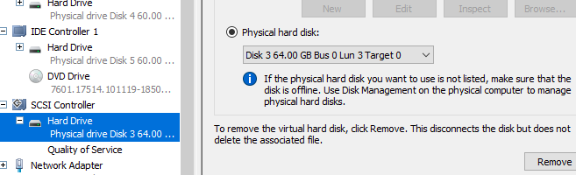
5. Select SCSI controller and add the restore data disk. When finished it should look something like the below screen shot:

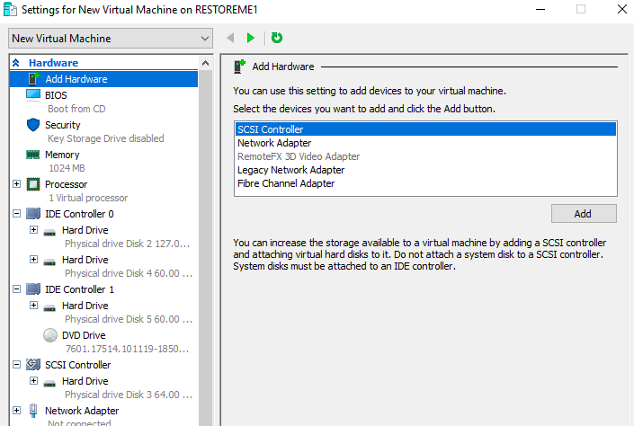

* You are now ready to restore

**Restore:**

1. Right Click your newly created VM,
2. In the upper left hand corner there’s a green button to start the VM. Click it and keep pressing space bar to boot from dvd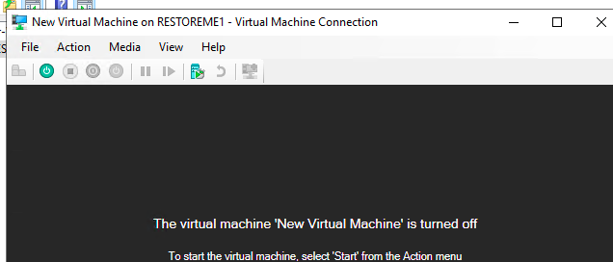
3. You’ll have only once choice “Windows Setup [EMS Enabled]” Hit the enter button.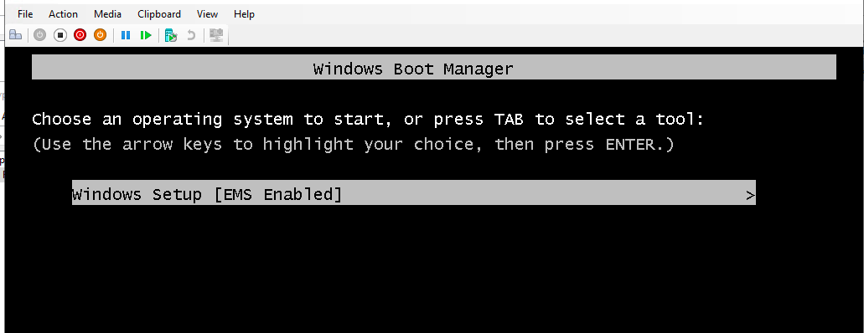
4. Click next at the Windows Setup Splash Screen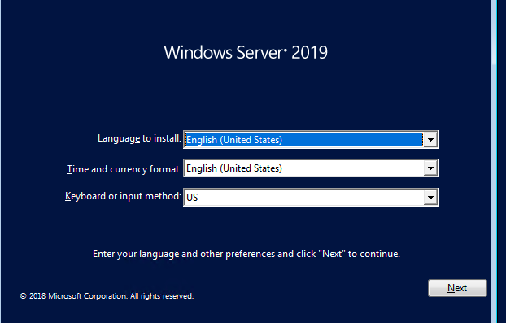
5. On the Bottom Left select “Repair your computer”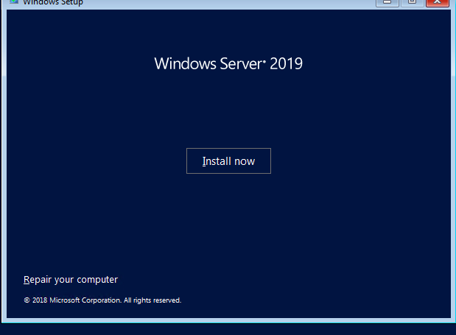
6. In “Choose An Option” select “Troubleshoot”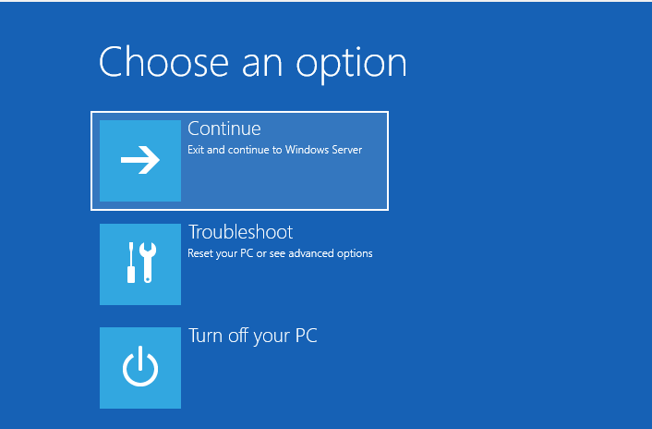
7. In Advanced Option. Select System Image Recovery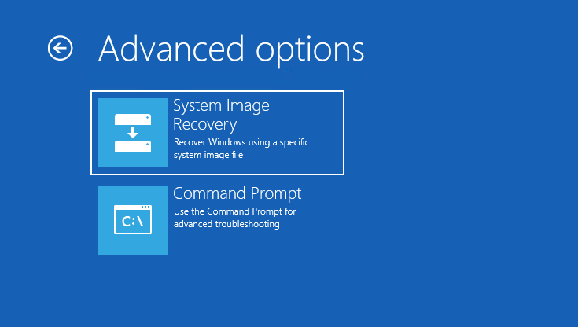
8. Under “System Image Recovery”, select “Windows Server”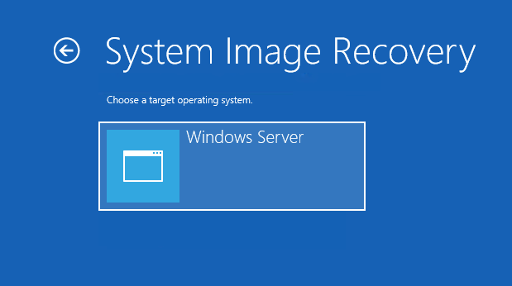
9. It will auto discover your restore data if you copied the directory properly.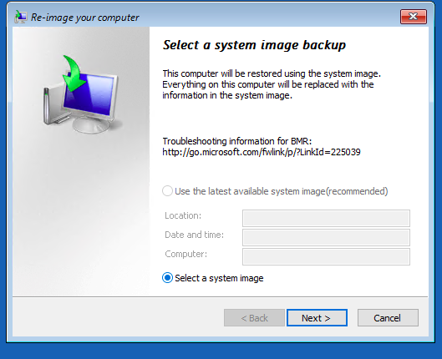
10. In the next 2 screens follow the prompts accordingly and verify what you want to do.

Post Restore Steps.

1. Depending on the situation and what you are doing. If you are doing a complete restore of active directory, you can shut down the restored vm. Leave everything as is. You will be mounting this into an azure drive next and it needs to keep DVDRom to allow azure to mount the install for the VM agents.
2. If you’re going to restore Active Directory completely you only to restore the servers and fix replication
3. If you ‘re doing an authoritative restore or something to that nature, do it in Hyper-V, because you can’t boot to DVDRom in Azure. The idea to fix it in hyper-v and recreate the vm in Azure. The offline disk mounts allows us to do this.
4. For authoritative restore, check if there is a second network card attached to the restore server, if not create one and attach it to the Active Directory subnet. After this is done, you can proceed to onward.

**Recreating Azure VMs from restore:**

1. Next modify the restore server unmount the disks, and remount dc2 if you need to and repeat the steps.
2. To create a vm, go to the top left corner of the portal, select All services, and search disks
3. Locate your disk, click your disk, and select deploy VM. Then fill in the blanks, you’re done.

**Summary:**

This process is very flexible and robust and is recommended in many disaster recovery plans. It’s also not very time consuming in the restores. Azure Backup Agent Bare Metal Restore can take upto 8 hours where this one will take 2 hours in total. server.

* For Generation 1 to Generation 2 upgrade, You only have to create a generation 2 disk and mount it into the Hyper-V restore server. Then run the Bare Metal Recovery
* For OnPrem migrations you only need to upload your backups to the restore VM onto a bootable drive Azure OS drive.

This is a script so you, copy the disk to a blob and allow you to create a managed disk from the blob to a machine that’s on a different Availability Group. Just fill in the blanks

import-module az

$creds=get-credential

connect-azaccount -credential $creds

#Provide the subscription Id of the subscription where managed disk is created

$subscriptionId = "Subscription ID"

#Provide the name of your resource group where managed is created

$resourceGroupName ="rf1-rg"

#Provide Shared Access Signature (SAS) expiry duration in seconds e.g. 3600.

$sasExpiryDuration = "36000"

#Provide the managed disk name

#$diskName = "name of disk you want to move"

#Provide the name of the destination VHD file (Blob) to which the VHD of the managed disk will be copied.

$destinationVHDFileName = "VHDFileName"

#Provide storage account name where you want to copy the underlying VHD of the managed disk.

$storageAccountName = "Destination Storage Account Name"

#Name of the storage container where the downloaded VHD will be stored

$storageContainerName = "Destination Container"

#Provide the key of the storage account where you want to copy the VHD of the managed disk.

$storageAccountKey = 'DESTINATION KEY '

# Set the context to the subscription Id where managed disk is created

Select-AzSubscription -SubscriptionId $SubscriptionId

#Generate the SAS for the managed disk

$sas = Grant-AzDiskAccess -ResourceGroupName $ResourceGroupName -DiskName $diskName -DurationInSecond $sasExpiryDuration -Access Read

#Create the context of the storage account where the underlying VHD of the managed disk will be copied

$destinationContext = New-AzStorageContext -StorageAccountName $storageAccountName -StorageAccountKey $storageAccountKey

#Copy the VHD of the managed disk to the storage account

Start-AzStorageBlobCopy -AbsoluteUri $sas.AccessSAS -DestContainer $storageContainerName -DestContext $destinationContext -DestBlob $destinationVHDFileName